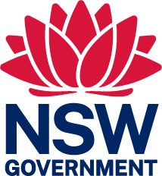
Mining, Exploration and Geoscience
Department of Regional NSW

This form is currently unavailable please contact titles@regional.nsw.gov.au for assistance.

RDOC22/130594 1

