Small mines risk profiling tool

Tier ranking tool for small mines
March 2024

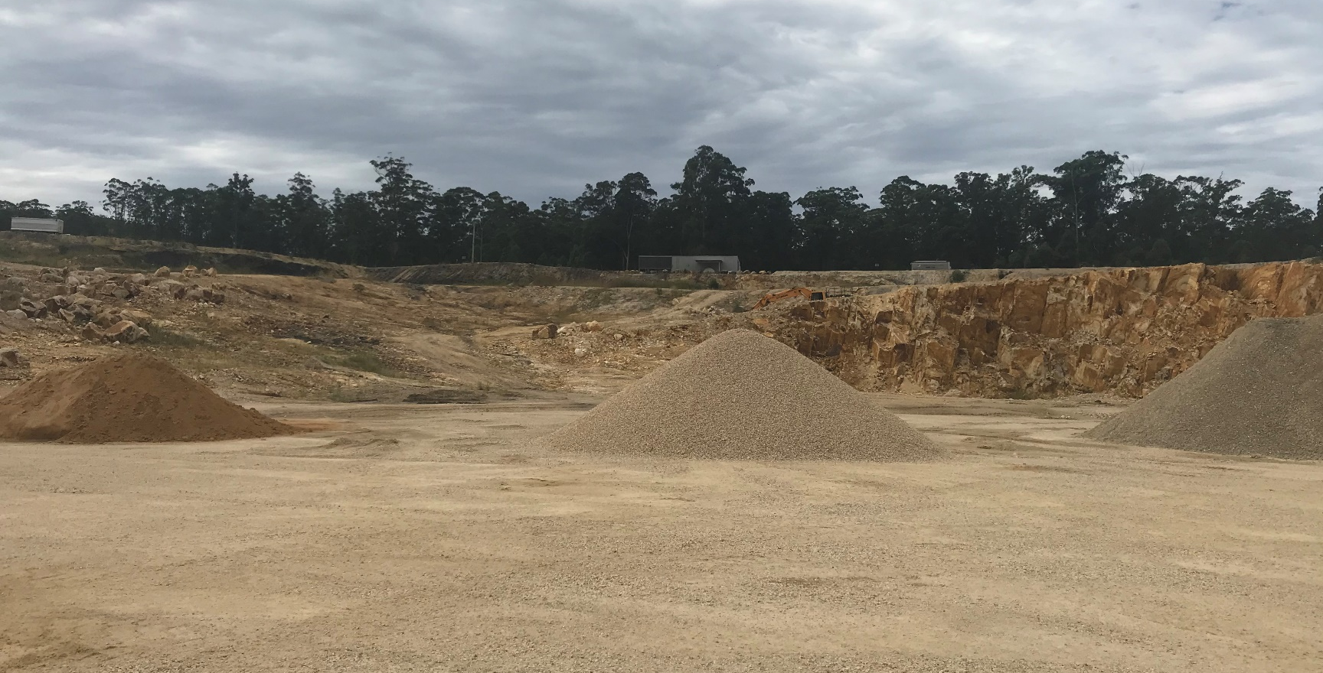

Published by the Department of Regional NSW

Title: Small mines risk profiling tool
First published: December 2016
Department reference number: MEG/INT17/265623
Amendment schedule
Date | Version | Amendment
March 2024 | 4.0 | Update to current template. Removed referenced to quarry manager with mine specific practicing certificate
May 2022 | 3.0 | Categories and ranking added to question 6
June 2020 | 2.0 | Addition of tier 3 quarry criteria
December 2016 | 1.0 | Original document
© State of New South Wales through Regional NSW 2024. You may copy, distribute, display, download and otherwise freely deal with this publication for any purpose, provided that you attribute Regional NSW as the owner. However, you must obtain permission if you wish to charge others for access to the publication (other than at cost); include the publication in advertising or a product for sale; modify the publication; or republish the publication on a website. You may freely link to the publication on a department website.
Disclaimer: The information contained in this publication is based on knowledge and understanding at the time of writing ([February 2024]) and may not be accurate, current or complete. The State of New South Wales (including Regional NSW), the author and the publisher take no responsibility, and will accept no liability, for the accuracy, currency, reliability or correctness of any information included in the document (including material provided by third parties). Readers should make their own inquiries and rely on their own advice when making decisions related to material contained in this publication.

Introduction
General information
Mine name (as listed in ACES): |  | Mine operator (as listed in ACES):
Inspector/mine safety officer name: |  | Date of assessment:
Inspector/mine safety officer signature: |  | Eligible score =

Tier 3 Quarry assessment
 | Tier 3 Quarry Criteria | Yes/No | Notes (if applicable)
1 | Has 5 or less workers full-time equivalent workers (FTE), including the quarry manager and contractors, and
2 | Does not carry out any dredging or blasting (explosives) activities on the site, and
3 | Does not extract more than 30,000 cubic metres of extractive material for sale or reuse per year
** If the site meets the above 3 criteria (yes to each), do not complete the rest of the profiling tool. Site is to be marked as a tier 3 quarry and a practising certificate is not required.

Risk profiling assessment

Nature and complexity of operations
 | Hazard/variable identified and scoring for possible risk | Score | Comments
1 | Number of full-time equivalent workers engaged in mining operations* at the mine (contractor, part time or full time)  (Scale - for each 2 workers, scoring of 1 point, 20 workers or more is a maximum scoring of 10)  *Mining operations are defined in the WHS (Mines and Petroleum Sites) Act section 7
2 | Crushing and screening on site (up to a maximum scoring of 10)  - Basic mobile crushing and screening plant – up to 5 items (1 point for each item up to 5 for a maximum 5 points)  - Large (complex) fixed or mobile crush and screen plant (6 – 10 points depending on number, size and complexity e.g, a score of 10 relates to a large, hard rock metalliferous mine etc)  Note: A current process flow diagram of the plant may be requested from the mine operator.
3 | Number of pieces of operating heavy mobile plant (such as excavators, loaders, trucks and auxiliary plant (includes EWP, crane, skid steer) up to a maximum scoring of 10 (1 point for each, maximum of 10 where there are 10 or more pieces)  Note: sites with extensive and complex on-site maintenance workshops for heavy plant should receive maximum 10 points
4 | Multi shift sites (maximum scoring of 10 based on maximum scheduled/actual shifts including back shifts e.g. maintenance)  - Intermittent operations (1 Point)  - Mon – Fri - Single shift (2 point)  - Mon – Fri & Sat sales only (3 points)  - Mon – Fri & Regular weekend prod or maintenance (5 points)  - Mon – Fri Two shift operation (can include weekend) (e.g. day & afternoon shift) – 7 points  - Continuous shift operations - 24/7 shifts (10 points)
5 | Continuity and output of mining operations (maximum scoring of 10 based on total excavated material, including overburden and imported material, and not just product): (Based on previous year’s figures, unless a known disproportionate increase is going to occur)  • 0 – 100 k tpa (1 point)  • > 100 - 200 (2 point)  • > 200 - 400 (4 point)  • > 400 - 600 (6 point)  • > 600 - 800 (8 point)  • > 800 (10 point)
6 | Any processing as part of mining operations where heat or chemicals are used e.g:  - Asphalt plant, kiln, treatment plant (scoring of 10)  - Gas fired dryers (scoring of 5)  - Pug mill, laboratory, small-scale processing plant (scoring of 3)  - Any other plant should be ranked and scored against the list above based on risk.

Principal control plan
 | Principal control plans | Score | Comments
7 | Explosives used on site (scoring of 10)
8 | Electricity used on site (up to a maximum scoring of 10):  - generator/s - total capacity up to & incl 25 KVA, (240V & 415V) – 2 points  - generator/s - total capacity over 25 KVA, up to & incl 50 KVA – 3 points  - generator/s - total capacity over 50 KVA, up to & Incl 250 KVA – 6 points  - generator/s - total capacity over 250 KVA, up to & incl 500 KVA – 8 points  - generator/s - total capacity over 500 KVA – 10 points  - mains supply from a supply authority (240V – 3 points)  - mains supply from a supply authority (415 V – 9 points)  - mains supply from a supply authority (high voltage (11,000V) – 10 points)  - total connected load at the mine exceeds 1,000 kW – 10 points
 | Sub total (maximum scoring of 80)

Principal hazard
 | Principal Hazard (scoring as per WRAC in this document) – to be considered as uncontrolled risk | Score | Likelihood | Exposure | Comments
9 | Ground failure
10 | Inundation or inrush
11 | Roads and other vehicle operating areas
12 | Air quality or dust or other airborne contaminant (if > 5% SiO2 consider ‘moderate or above’)
13 | Fire or explosion
14 | Any other principal hazard
15 | Subtotal (no maximum score – depends on the principal hazards)  Other risk factors to consider where an elevated risk profile for the mine may exist (max score of 10 in total):  - working at height  - confined spaces  - chemical hazards  - hazards from the mining operations that are risks to persons outside of the mine (eg. near to residential area, infrastructure used by people such as road, rail, airports etc)  - other:  Subtotal (maximum 10)
 | Total (90 or more = Tier 1 quarry)

Workplace risk and control (WRAC) matrix
A B C D E  1 1 2 4 7 11  2 3 5 8 12 16  3 6 9 13 17 20  4 10 14 18 21 23  5 15 19 22 24 25 | Likelihood (frequency of occurrences)] | Exposure (number of people exposed to principal hazard)
 | A Rare Only occur in exceptional circumstances  B Unlikely Could occur at some time  C Moderate Should occur at some time  D Likely Probably occur in most circumstances  E Almost certain Expected to occur in most circumstances | 1 1-2  2 3-5  3 6-10  4 11-24  5 25+

Examples of scoring for WRAC
Scenario 1 | Scenario 2 | Scenario 3
Quarry with 15 workers (incl. contractors) where the principal hazard of ground instability is present  Likelihood: B Unlikely  Exposure: 1 (1 - 2 i.e. actual number of workers to be exposed at location of hazard event i.e. not all the workers at the mine)  Risk ranking: (B1) = 2 | Quarry with 5 workers (incl. contractors) where the principal hazard of inrush is present (river operation – known flooding)  Likelihood: E Almost Certain  Exposure: 2 (3 - 5 i.e. actual number of workers to be exposed at location of hazard event)  Risk ranking: (E2) = 16 | Quarry with 30 workers (incl. contractors) where the principal hazard of air quality is present (crush & screen and high silica)  Likelihood: D Likely  Exposure: 5 (25+ actual number of workers to be exposed at location of hazard event e.g. everyone on site over a period of time will be exposed to dust)  Risk ranking: (D5) = 24

